**Getting started**

To start selling the products at Indomarche, you must register with us as a merchant!

For a merchant account, several subscription packages are available to choose according to the needs and the budgets. We have packages for free usage as well as for the professional ones. Visit the merchant page to register with us!

To get a brief understanding of a merchant account, please visit the stated links:

* [**Benefits**](https://indomarche.com/selling#benefits)
* [**Working**](https://indomarche.com/selling#howItWorks)
* [**Pricing**](https://indomarche.com/selling#pricing)
* [**FAQs**](https://indomarche.com/selling#faqs)

**Configurations**

To login to your merchant dashboard, please visit <https://indomarche.com/login>.

Before starting to sell on IndoMarche, please configure your shop first for better understanding and performance. While configuration, you follow certain steps to set-up your shop on the portal. To start with the same, you must configure at least one payment method to get all the payments for the sales. Also, you must add a shipping zone too to allow the customers to make the orders from the shop.

We hope that you must have already registered with IndoMarche, so let’s start with our journey!

**Attention!** Some of the options might not be accessible to you due to certain rules of the marketplace, IndoMarche. To access any option that is not available and is a must for you, please reach out to us at merchant support helpline, or open a ticket!

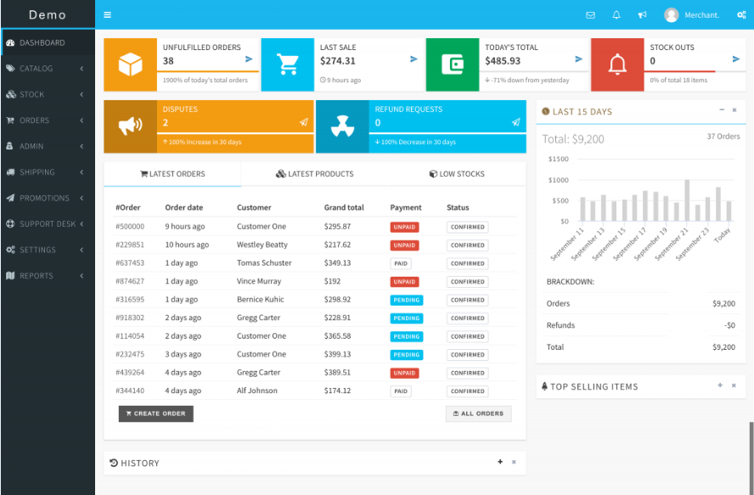

Here is a brief on what all is to be configured for a successful journey ahead!

* General Configurations
* Shop Settings
* Payment Methods
* Tax Settings
* Go Live
* Get Verified

**General Configurations**

The initial step in the configuration is setting up the brand information of your business. For this, you must add several details like the business name, its logo, your cover image, the physical location of the business, and many more.

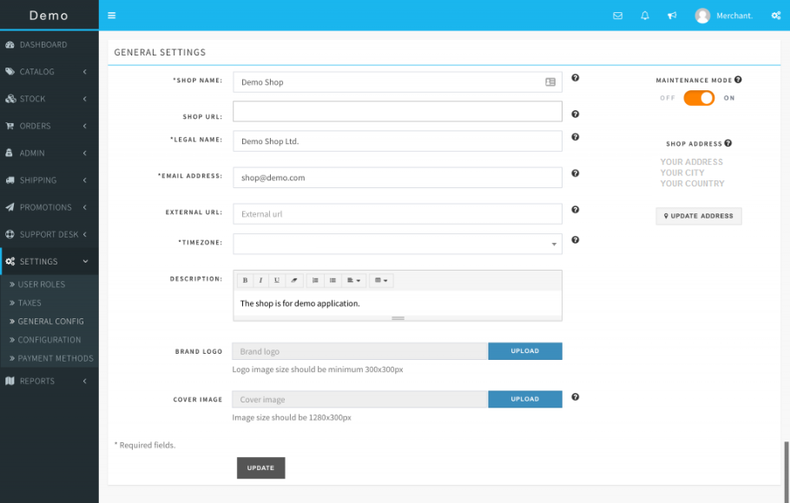

**Shop Settings**

This is all about your virtual shop store at IndoMarche’s portal and here you can manage everything about it including the inventories, orders, notifications, and also the supports.

SETTINGS >> CONFIGURATIONS

-----------------------------------------

*INVENTORY*

ALERT quantity level can be set for your shop to get the notification via Email whenever an item goes below the limit and hence helps ensure fast actions on any changes.

*Notification can be turned off too by visiting the notification settings.*

SETTINGS >> CONFIGURATIONS >> INVENTORY

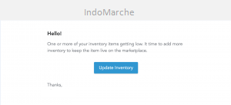

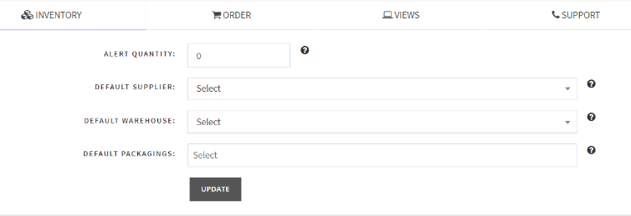

*ORDER*

To set the order rules, you can access this section! You can set the handling cost that is the extra cost to be added with the orders’ shipping costs during the checkout. In this section, you can also set the prefix and suffix for the order number to set the defaults for payments, order tax, etc.

SETTINGS >> CONFIGURATIONS >> ORDER

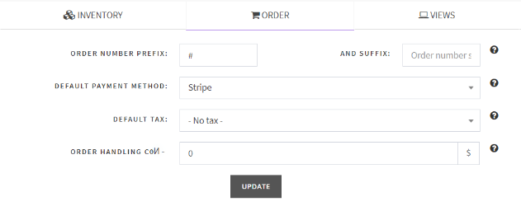

*SUPPORT INFORMATION*

You can set customer support information like Email, phone number, or address, wherever you wish to solve the issues of the customer. Default sender Email and name can also be set here.

SETTINGS >> CONFIGURATIONS >> SUPPORT

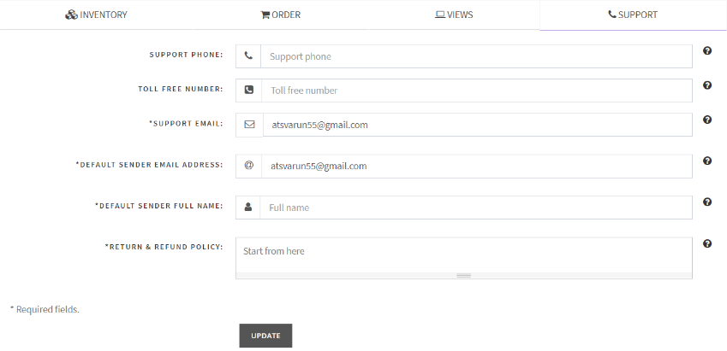

*NOTIFICATION SETTINGS*

This section is the turn the notifications on or off.

SETTINGS >> CONFIGURATIONS >> NOTIFICATIONS

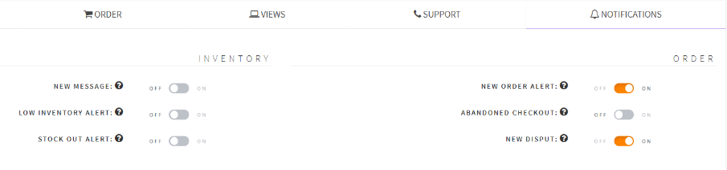

**Payment Methods**

Setting the payment methods is among the most significant steps of the configurations before going live on the IndoMarche’s portal. There must be at least one payment method activated to get instant payments on every order confirmation by the customers. To get the in-depth directions for the same, visit the configuration page.

**Warning!** Unless there is an active payment method available on your store account, your product listing will not be visible to the customers.

SETTINGS >> PAYMENT >> METHOD

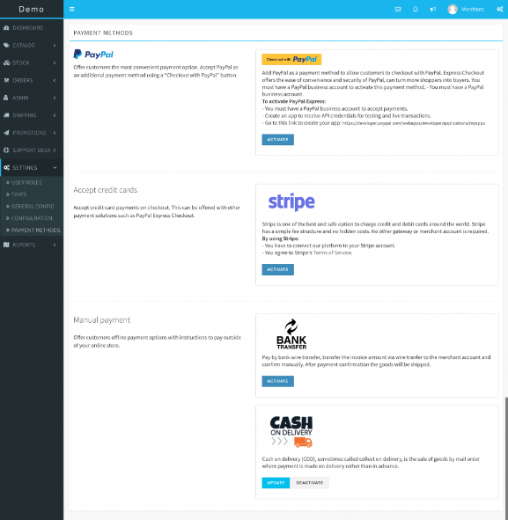

**Attention!** Some options might be hidden from you because of the configuration of the marketplace! To access any of the hidden options, please reach out to us at the customer support helpline.

**Tax Settings**

You can list all the tax profiles here for your products. Once you are done creating the tax profiles, later while creating the shipping zones, these tax profiles will be linked with the shipping zones.

SETTINGS >> TAXES

**Go Live**

Everything is configured now, and it is time to go live. Turn OFF the MAINTENANCE MODE, and confirm to move further.

SETTINGS >> GENERAL >> CONFIG



Hurray! Your shop is live now.

**Get Verified**

Verified sellers are preferred more by the customers, hence ensuring better sales for their shop stores. A verified tag makes the customers feel comfortable and secure and gets assured of the quality. Get verified now, and win a shiny *Verified badge!* *https://support.incevio.com/wp-content/uploads/2019/09/verified_badge-20x20.png*

ACCOUNT >> PROFILE

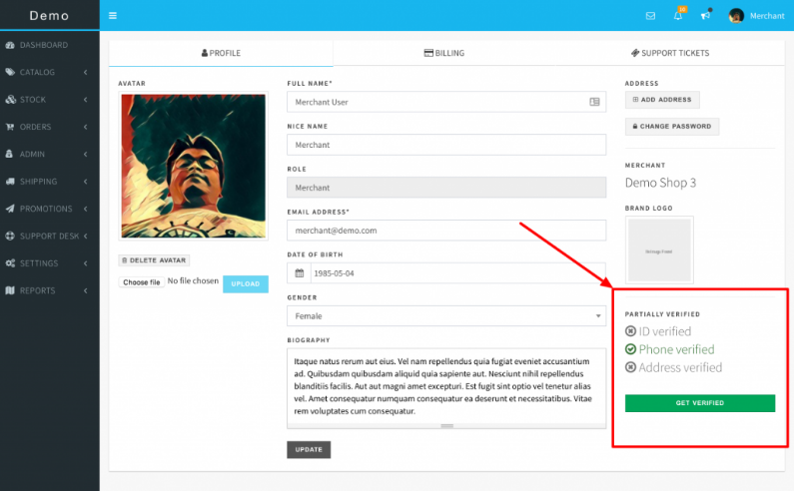

There is a verification status available at your profile, click over GET VERIFIED to submit all the required documents and get the verified tag.

ACCOUNT >> PROFILE >> GET VERIFIED

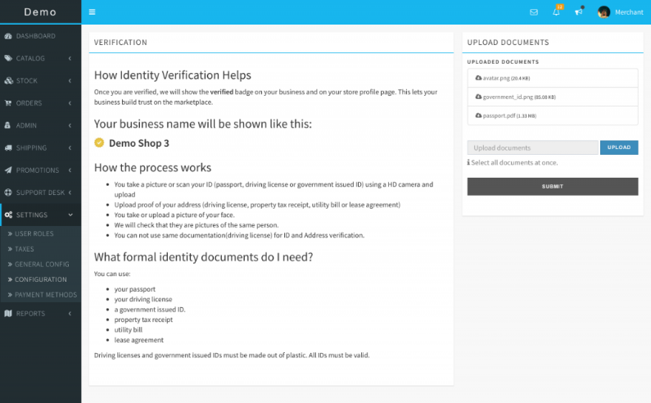

Go through the instruction and follow the same, and finally submit all the required documents. Further, the team of IndoMarche will verify and review all the submitted documents and will take the required measures to complete the process.

**Shipping**

This section is there to set up all the modules related to the shipping of your products. Several details like shipping zone, carrier, cost, packaging, and many others are required here.

Here is what all is required in this section:

* Shipping Zones
* Shipping rates
* Shipping Carriers
* Packaging

**Shipping Zones**

These are the areas where your products and services are accessible and where you are doing your business. Customers of these zones only can access your products from the store at IndoMarche’s portal. You can select and save as many shipping zones as you want. There is also an option of a worldwide shipping zone available to cover all the areas across the globe that are excluded from the other zones.

**Warning!** Without an active shipping zone, your product listing will be hidden from the customers.

SHIPPING >> SHIPPING ZONES

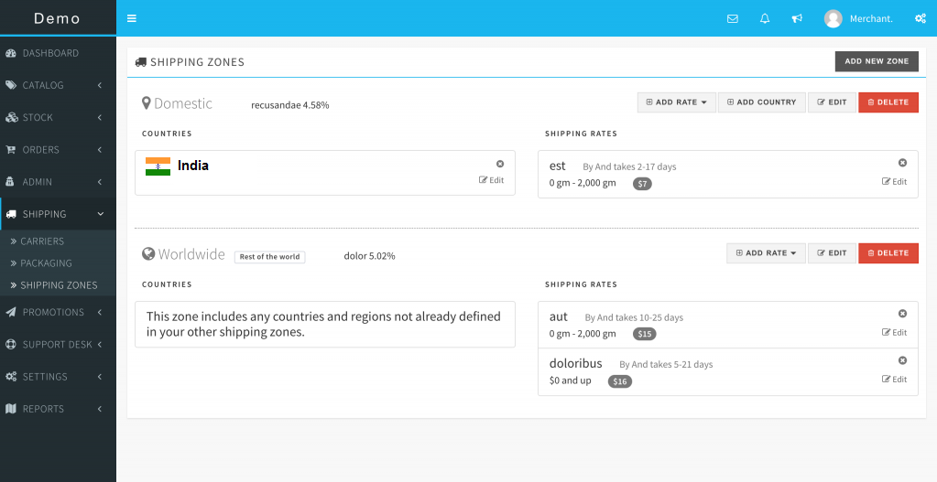

**Shipping Rates**

Multiple shipping rates can be created from a single shipping zone. Also, the shipping rates can be dependent on the PRICE and the WEIGHT too. The shipping carrier that is used can also be linked to develop the confidence and trust among the buyers.

SHIPPING >> SHIPPING ZONES >> ADD RATE

**Attention!** For the shipping rates that are based on the weight, they must be added along with a product description for the reference.

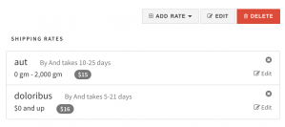

*Based on Price:*

Lower and Upper limit of the price must be set for the rate. This option will only be visible to the customer if their cart value (total order price) is within the price range.

*Based on Weight:*

You must set the lower and upper limits for the weight to set the rate accordingly. The option will only be visible to the customer if the total order weight lies between the set ranges.

**Warning!** If you select the FREE SHIPPING option, then the shipping charges will remain zero irrespective of the set rate.

**Shipping Carriers**

Shipping carriers can be added and linked with the shipping rates. They are visible to the customers on selecting the shipping option.

SHIPPING >> CARRIERS

**Packaging**

This is an optional yet recommendable feature to be available in some options for the customers. They are recommendable as it increases the buyers’ interest whenever they want to access any special packaging for a gift or a surprise. The availability of packaging gift wraps might make your customers happier!

SHIPPING >> PACKAGING

**User Management**

More users can be added to the account as the staff members to ease the handling of the business’s store. The added users have varying permissions according to the allotted roles. The merchant owns the store and has complete access over it, and he/she can decide the access of the staff members.

**Attention!** The users have higher privileges that you cannot be modified by you. You only have access to add/modify the users with lower privilege than yourself.

Other points are there too to be viewed about user management, they are:

* User Roles
* Create Users

**User Roles**

To access the system, the user must have been allotted some roles. User roles can be created by you or also by the IndoMarche platform itself. If you have the permission of creating the user roles, then you must also set the permissions for them.

SETTINGS >> USER ROLES

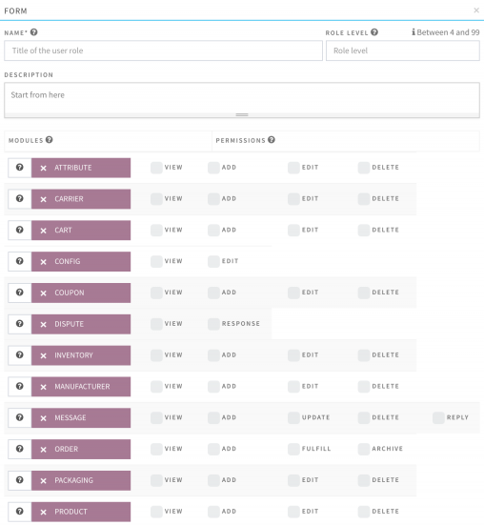

**Create Users**

Depending on your subscription package, you can also add the users to your account. Creating a user is pretty easy; you just need to provide some basic information about the user and save the changes. The user can then login and update his/her profile.

ADMIN>>USERS

**Manage Catalog**

The catalog has several elements like the category, product attributes, product modules, and manufacturer modules. This section helps you to easily and smoothly manage the product catalog of your marketplace. It has all the functionalities embedded that are necessary!

**Attention!** There might not be complete access to all the modules of the catalog section due to certain marketplace rules.

Elements involved with this module are the ones mentioned here.

* Categories
* Product Attributes
* Products
* Manufacturers

**Categories**

This entire module is categorized into 3 subdivisions that are group, sub-group, and category. The *Category group* is the initial division for grouping the listed product and organize it. There can be multiple *sub-groups* in a category group, and there can be multiple *categories* under a sub-group.

CATALOG >> CATEGORIES

**Attention!** If you cannot see the option for a category in your navigation menu, then there might be a case that the vendors are not allowed access to this module by the admin of the marketplace. For having access, you can make a request to the admin for complete or partial access to this module. You can request for the desired category to be available for using it for the product listings.

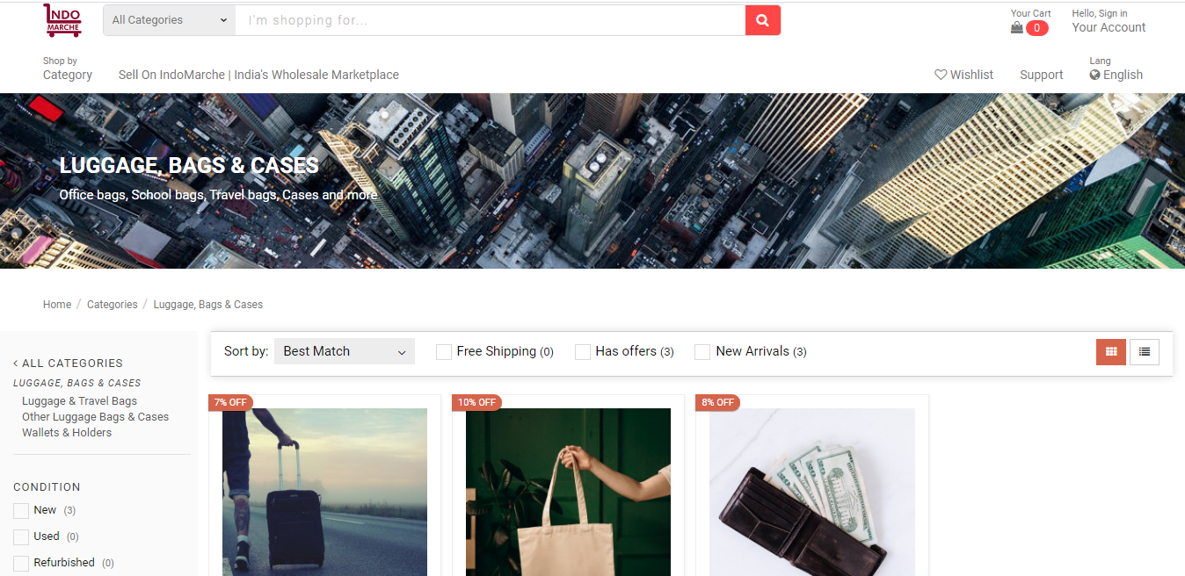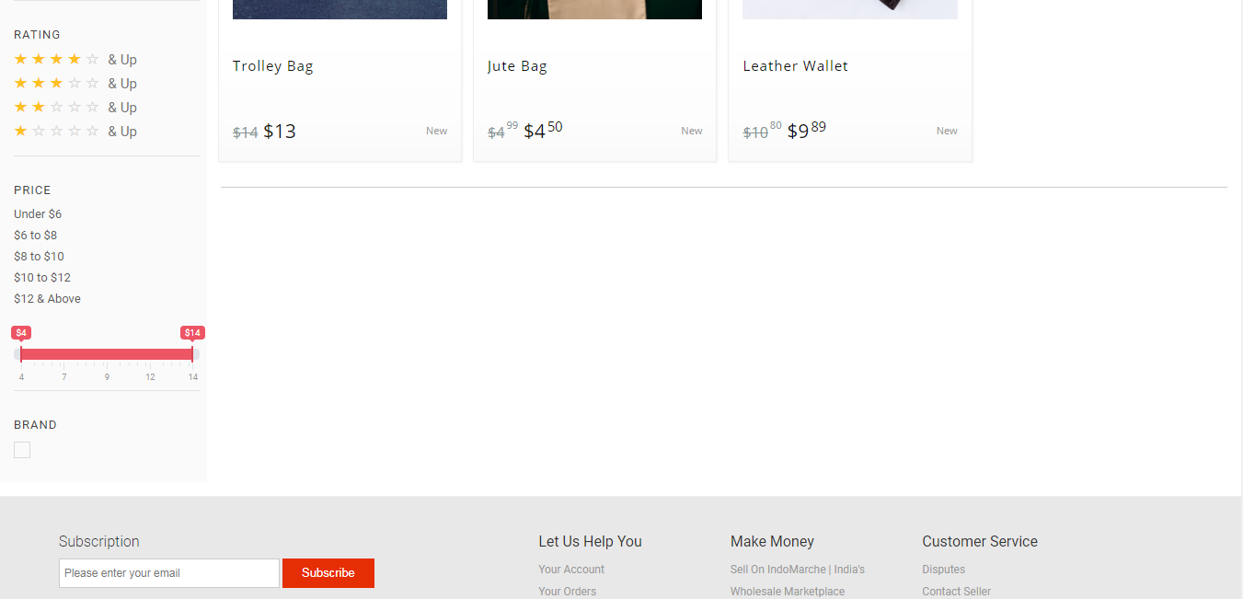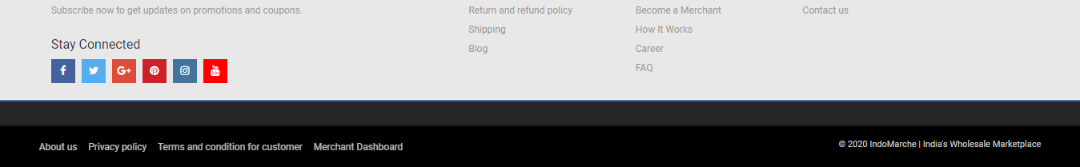

*Category Groups*

The category listing can be done for your product that is visible on the marketplace’s landing page, where the customers/ visitors navigate to through the *Shop by Category* dropdown. A catchy icon is set at the left side of the dropdown list. Inside that, several icons are embedded that allows searching for the products in the respective categories.

CATALOG >> CATEGORIES >> GROUPS

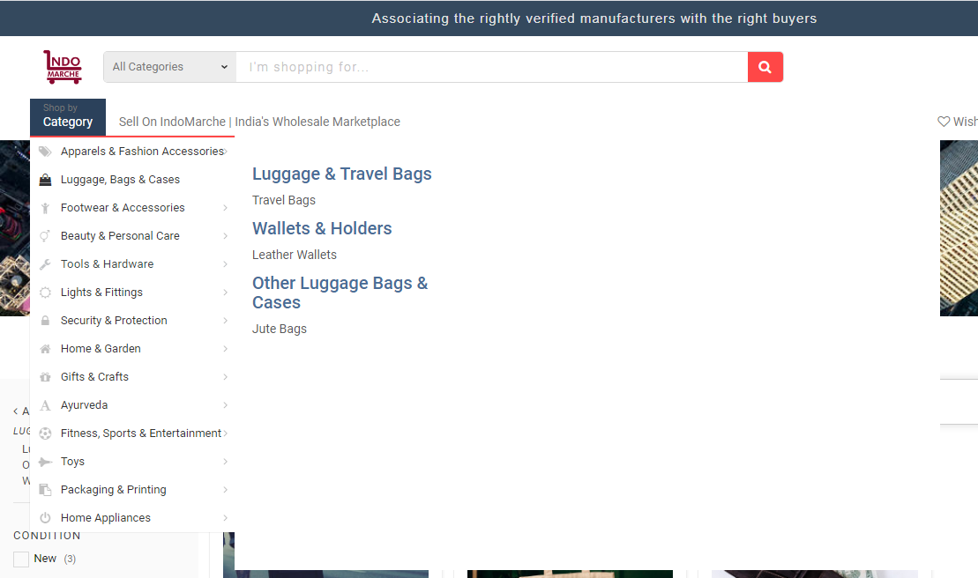

*Category Sub-group*

It can be considered as the parent category of the end categories that are labeled. It can hold many end categories that are helpful to organize the catalog efficiently.

Having a glance over this section will ease the managing of the sub-groups!

CATALOG >> CATEGORIES >> SUB-GROUPS

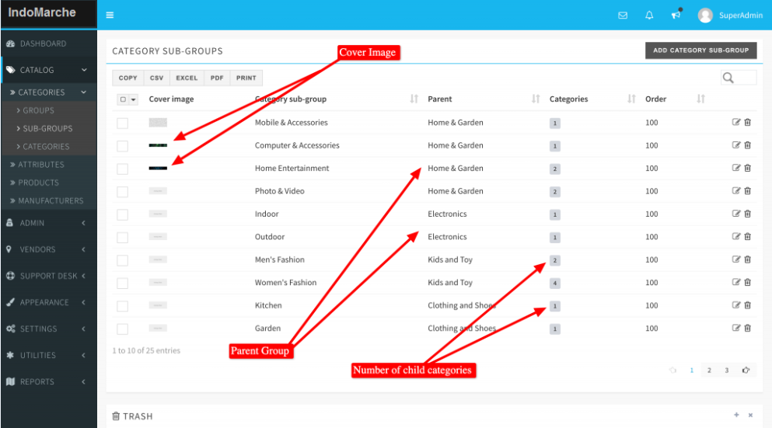

*Category*

It is the final and last label. All the products come directly under this section. An image is set to get the right information about the products included in the category.

CATALOG >> CATEGORIES >> CATEGORIES

**Warning!** If the admin removes or deletes any parent Group of Sub-group, then all the child entities associated with that get removed too.

**Product Attributes**

Three types of product attributes are available with IndoMarche.

*Color/Pattern:* This is a unique attribute type. In this, the image of the color or the pattern can be selected as an attribute value and it will also be shown as an option on the product page. These images are displayed on the description in place of the attribute name. However, these images are meant to be the tiny ones to fit in properly.

*Radio:* This is the basic radio attribute type. Here, a dropdown box is shown as a list of options on the product page.

*Select:* This attribute type is similar to the radio type and in this too a dropdown box is shown with the options on the product description page.

CATALOG >> ATTRIBUTE

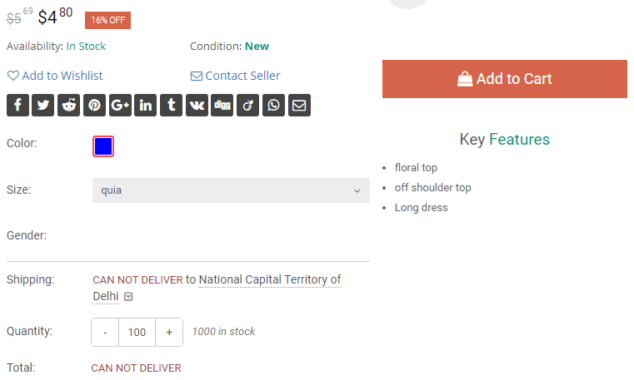

**Products**

It is a prime module of the catalog section with an array of options available. This is a generic description of the product along with some steps and set of rules to ease the addition of the product listings for the merchants. A product can have unlimited listings from several merchants dealing with it. On deactivating the product from here, all the listings of that product go offline from the storefront, and thus the merchant has no right to deactivate it.

Merchants are allowed to add/edit the products to the catalog if they wish to!

**Attention!** A product added by a merchant can only be deleted by him/her if there are no more listings available for that product.

CATALOG >> PRODUCTS

*Catalog Rules:*

You can decide and set if the product can be added with multiple variants and whether you want to ship the physical item or not. Price boundaries might also be set for an item to allow you to set a price within the limits for listing that in the inventory. This is mandatory to keep the marketplace safe from frauds and unwanted listings.

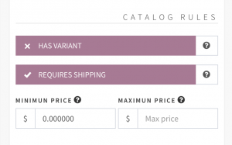

*Product Images:*

Multiple images and featured images too might be there from the admin or the one creating a product. The images will only be visible if there is no image available in the other merchant’s listing. This is completely based on the choice to add a default image with the product or not. A featured image is however preferred to ease the product searching for the merchants while creating a listing.

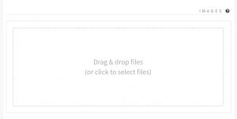

**Manufacturers**

Manufacturers or brands can be managed with the help of this module. The visitor/ customers of IndoMarche will be able to visit the Brand page to check all the listings from the same brands coming from the different merchants. This is necessary to add extra value to the portal.

CATALOG >> MANUFACTURERS

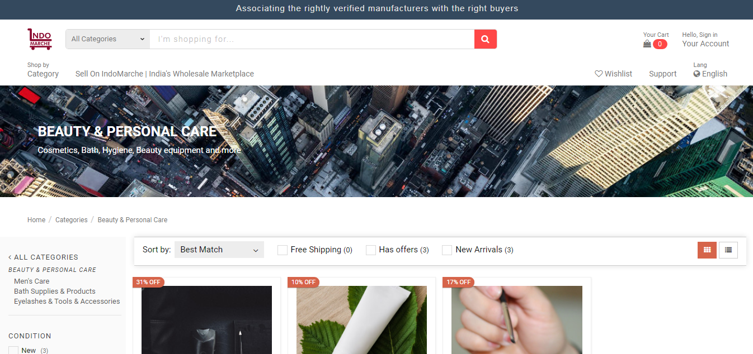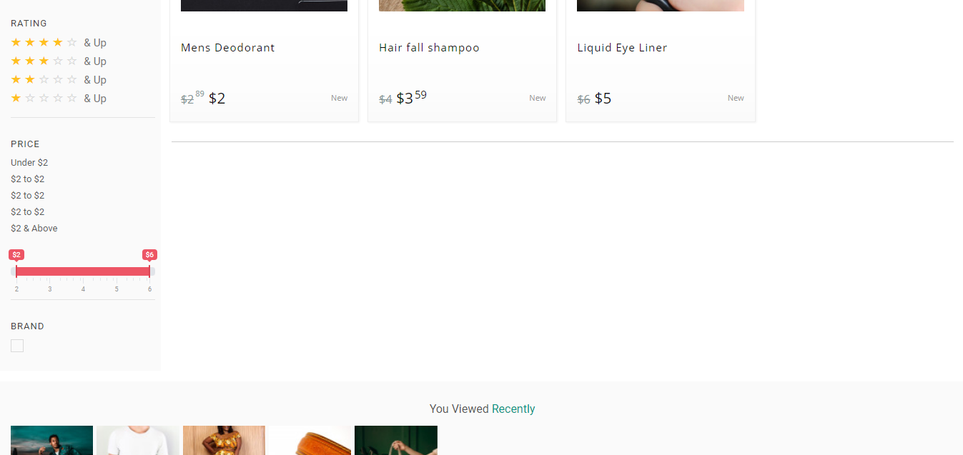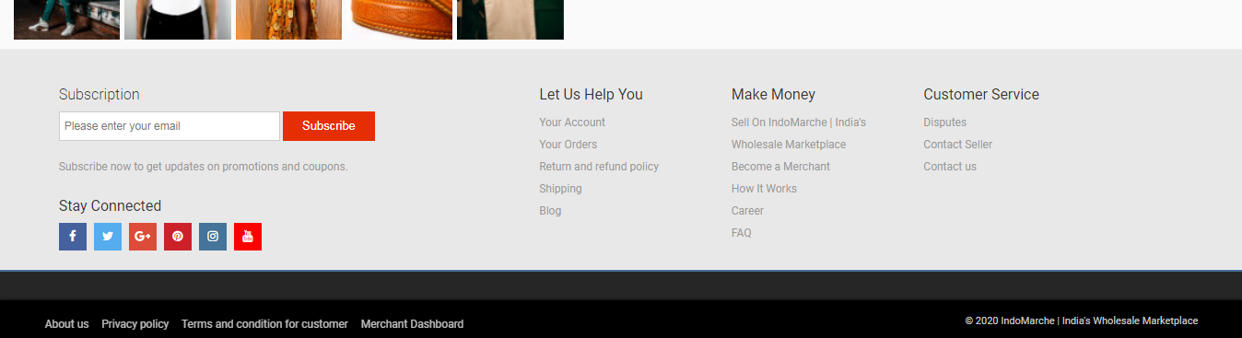

**Stock management**

This is the back office for managing your stock including inventories, suppliers, and warehouses. The inventories are divided into three different lists by the system, which is as follows:

* Active Listing
* Inactive Listing
* Out of Stock

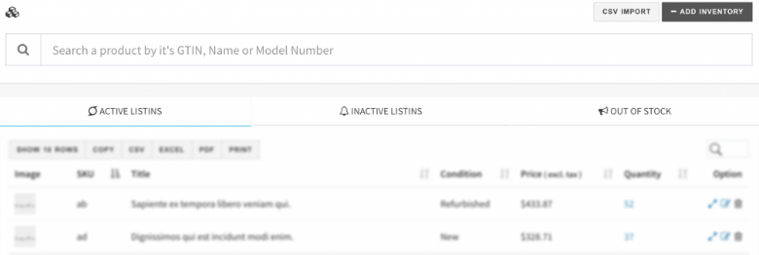

Several features for stock management are there with IndoMarche that are:

* Suppliers
* Warehouse
* Add Stock
* Bulk Upload

**Suppliers**

All of the supplier profiles can be set up in the system with this module. With each new addition in the inventory, you will get access to select the supplier for the same.

STOCK >> SUPPLIERS

**Warehouses**

All of the warehouses available with you can be added to the system. With each product’s addition in the inventory, you can select the warehouse from where the product will be shipped.

STOCK >> WAREHOUSE

**Add Stock**

To add a product to your stock, you must click on the ADD INVENTORY button. If there is a possibility to create a variant in the inventory, then ADD TO INVENTORY WITH VARIANT option will be displayed, otherwise, ADD TO INVENTORY button is shown. You can select the right option from the available ones that fit best for your needs. Be honest with everything thinking from a buyer’s perspective.

STOCK >> INVENTORIES >> ADD INVENTORY

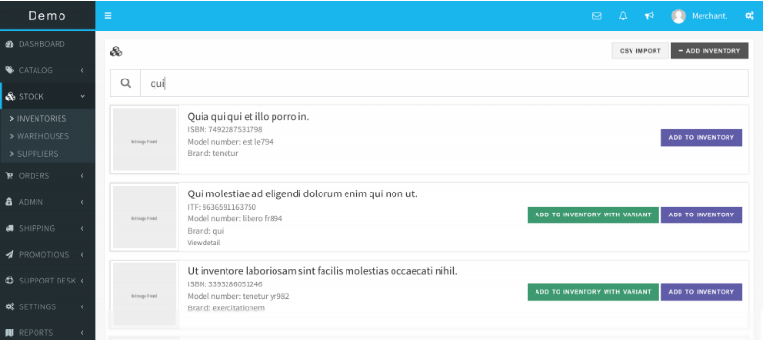

If you cannot find a product, then it must be unavailable on the marketplace yet. To solve this issue, you can create the product by visiting the CATALOG PRODUCTS section and then add the inventory.

*Basic Info*

This section contains all the information parts that are required for the description of a product. Carefully add the title and listing, as it solely should be enough to give an idea of the product, and then the description must be there with in-depth detailing of the product. It must have everything about the product that the customer might want to know.

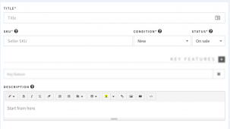

*Images*

This is the most crucial part of the product description in your listing. Mostly, the items with a quality image are preferred by the buyers. Also, you can add multiple images of your product taken from different angles to provide every fine detail.

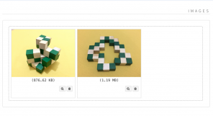

*Key Features*

It is a feature list expressed as the bullet points and is available at the top of the product description and detailed page. Adding this key feature list is highly recommendable as it helps improve the attraction for the customers. Also, the information in the list must be the main and important ones.

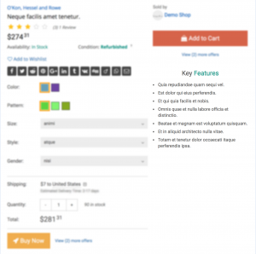

*Listing Rules*

It is the module that helps to list all the rules related to your stock like the number of products in the stock, the minimum amount of a certain product that a customer can buy, and pricing for the single units. Promotional prices and offers can be provided too for a limited period.

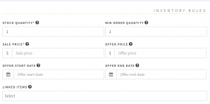

*Shipping Info*

All the shipping details including how the shipping will be provided, everything about the packaging, the shipping weight, the shipping cost, and all other related details are included from this module.

**Warning!** For weight-based shipping charges, the weight must also be added to the shipping info.

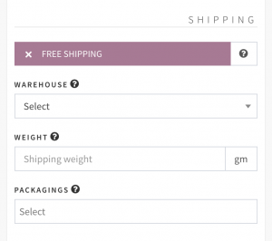

*Attributes*

SIZE, COLOR, STYLE, and other attributes can be added with this module. The attributes can also be added by your account if they are not visible, for this you must choose from the CATALOG ATTRIBUTE section.

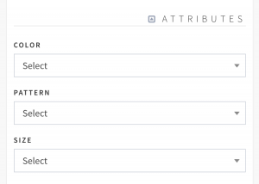

*Linked Items*

Related items with the product can also be added with a product listing to increase customer’s interest in your store and linked items too. These products will be shown as Frequently Brought Together. Only link the relevant items and not just anything!

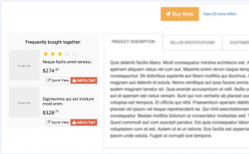

*SEO*

SEO friendly URL (SLUG) is a required field that can be automatically filled by the system itself. These are visible to the customers/ visitors when they visit the product page. With this feature, the marketplace, and eventually the store can directly attract the buyers from Google. Hence, this value is recommended to be set for higher customer acquisition.

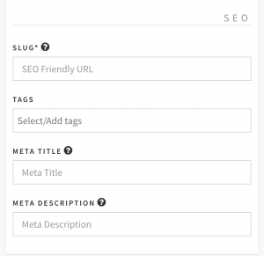

## Bulk Upload Inventory

## Inventory information can be bulk uploaded by CSV too. All the required instructions and templates are available on the CSV upload page for your reference.

## STOCK >> INVENTORIES >> CSV IMPORT



**Order Handling**

This is the back office to help you handle the orders. From here, you can also create new orders, and the orders are displayed in three different lists that are:

* All Orders
* Unpaid Orders
* Unfulfilled Orders

ORDERS >> ORDERS

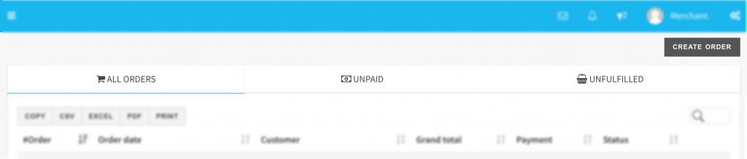

 This module has order handling sections that are:

* Order Fulfilment
* Create An Order

**Order Fulfilment**

To fulfill one order, visit ORDERS >> ORDERS, and then click over the UNFULFILLED tab, and then find the order that you wish to fulfill first. Now select the ORDER NUMBER on the #Order column of the table having the list of all the orders. Now, on the next screen, mark the orders as PAID or UNPAID.

**Tips!** Use the search box available at the top right corner to find the order from the order list table.

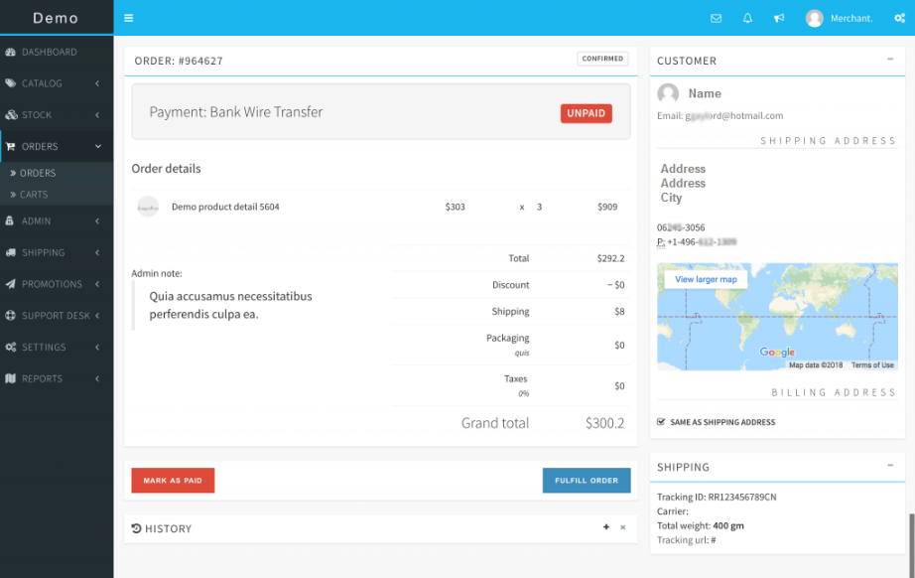

If you have already shipped and fulfilled the order, click on the FULFIL ORDER button to update the status. Moving on to the next screen, you can also select the shipping carrier and update the tracking details of the order so that the customers can track their shipments. A notification can also be sent to the customer for the updates.

**Create An order**

You might also need to create an order, and that is possible easily with the simple interface of IndoMarche that has all the features to create an order.

For creating an order, go to ORDERS >> ORDERS and then click on CREATE ORDER. On the next screen, find the customer for whom the order is to be created. As soon as you type the name, email, and other details, the result will be displayed. Select the customer and select the PROCEED button to populate the order form.

ORDERS >> ORDERS >> CREATE ORDER

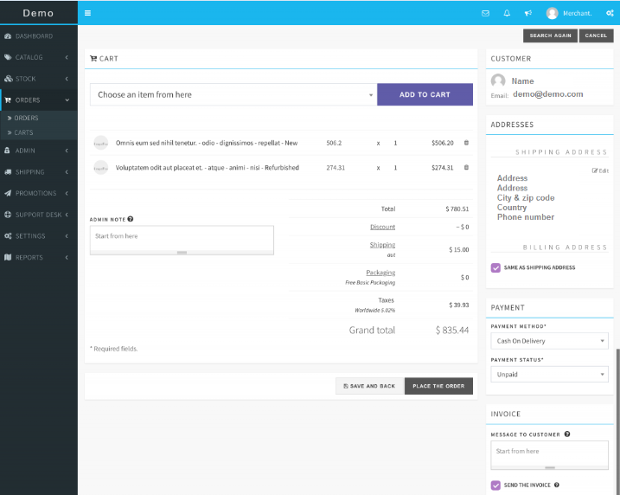

The screen of order creation is self-descriptive. To proceed later with the order and save it for the time being, you can just click on SAVE AND BACK button. And, to create the order, select the PLACE THE ORDER button.

*Use Saved Cart for creating the order*

To place an order from the saved items in the cart, go to ORDERS >> CARTS and find the cart to proceed with. Finally, click on the USE button to process the order

**Discount Coupons**

To attract the maximum number of customers, the best possible way is to offer discount coupons. Unlimited coupons can be created by your merchant account for your store. Also, you can complete the promotions for your store too. You can set several details for the discount coupons like the period for its availability, the total quantity of it, how many times each buyer can avail the benefits, and many more. The value of the coupon can be fixed or be depended on the percentage of the total order value.

PROMOTIONS >> COUPONS >> CREATE COUPON

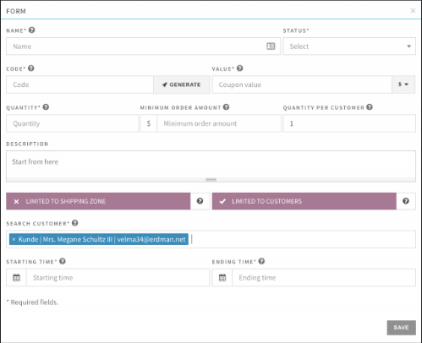

**Coupon for specific customer/s:**

To attract maximum customers, there must be a range of coupons usable for single or even the groups of customers. To limit the usage of a coupon to a single customer, check the LIMITED TO CUSTOMERS option, and from there, select the customer/s.

**Coupon for specific shipping zone/s:**

You can also create coupons that can only be accessible from some specific shipping zones. To limit the coupons to some shipping zones, select the LIMITED TO SHIPPING ZONE option and select the zone/s.

**Customer Support**

The IndoMarche system has built-in modules to handle customer supports. It has a complete inbox module where you can receive the messages, and also draft or send the messages. To handle the disputed orders, you are also provided with the dispute and refund modules.

All the modules that are available in this section are:

* Messages
* Dispute
* Refunds

**Messages**

This module is specially designed to communicate with the customers. With this module, you can personally chat with the customer through the messages.

SUPPORT DESK >> MESSAGES

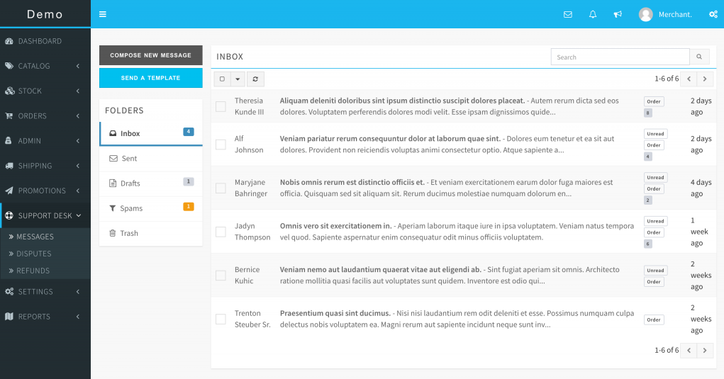

*Send an Email Template*

To send an email template that is already saved with you, select the SEND A TEMPLATE option when you want to compose and send it.

To create the Email templates with IndoMarche, go to SETTINGS >> EMAIL TEMPLATES. These templates can be plain texts or also Html texts.

**Disputes**

A customer can open a dispute to order if he/she is not satisfied with the delivered one. Initially, you will be the first one to receive the dispute, and you are advised to carefully handle these disputes as they affect your reputation on the IndoaMarche’s portal. If you are unable to solve their issue, or if the customer is not satisfied with your solution, then he/she can appeal the dispute. After this, IndoMarche’s support team will handle the dispute and solve the issue.

**Tips!** It is recommended to handle the disputes carefully and talk to the customers in a very polite and honest way.

SUPPORT DESK >> DISPUTES

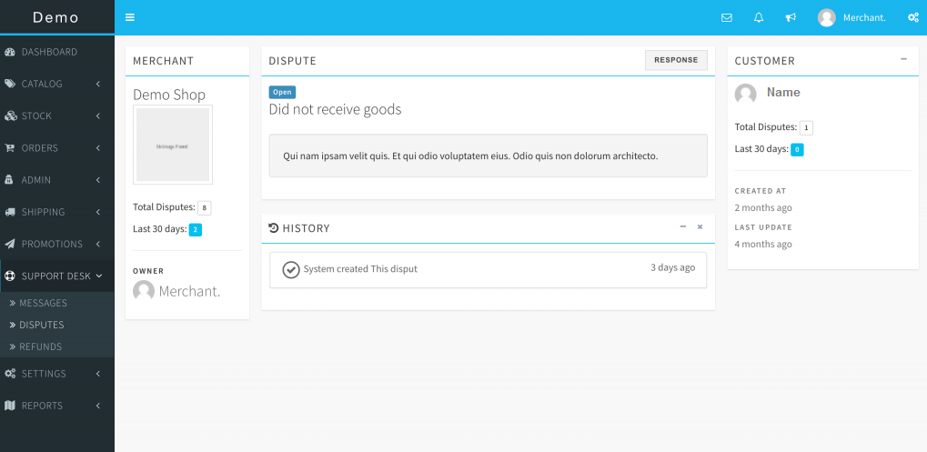

**Attention!** Only the support team of IndoMarche can change the status of the appealed disputes.

**Refunds**

When a dispute is opened by a customer, he/she can request for partial/ full refund for the order total too. You can initiate the refund too if you find it justified.

If you have complete permission to the system, you can also approve or decline the refund request from this section.

SUPPORT DESK >> REFUNDS

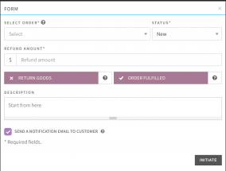

**Attention!** Initiating a refund will transfer the actual refund amount to the customer. Even after this, you will have to send the money from your account to the IndoMarche’s account.

**Reports**

This is the module that will provide a sharp view on the performance of your shop on the IndoMarche portal. Several reports are available like:

* Sales by month
* Conversion rates
* Top-selling items
* Top-grossing items
* Top customers
* Returning customers
* Abandoned customers
* Average order value
* Top-selling categories
* Top suppliers

Apart from the ones mentioned here, there are many more reports available with us with detailed insights.

REPORTS >> PERFORMANCE

**KPI**

KPI stands for Key Performance Indicator. It shows the sales report for the last 12 months and provides a financial overview of the whole year. You can check several things here like the conversion rate, total revenue earned in the last 12 months, the total number of carts left abandoned, average order value for your store, and many more.

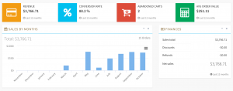

**Top Selling Items**

This section will provide detailed information about the top 10 items present in your inventory. Here there is a table for the same displaying the units sold and revenue generated from them. This is important to set marketing strategies and add inventories accordingly.

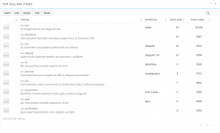

**Top Customers**

This is the list of customers who spend more on your store. This list can help you more in marketing and you can also offer them discounts and coupons to these customers to convert them into a returning buyer.

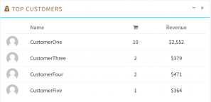

**Returning Customers**

This is the list of the frequent customers of your store. These are the most important customers because you do not need to do any marketing to maintain them. Also, you can offer discounts to them to make them happier with your services.

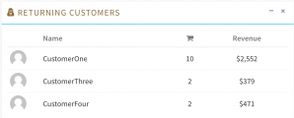

**Top Categories**

This is the list of your best performance categories. It also has a listing of all the products available in your store. This is the perfect list to get a proper idea of the trends and get the trendy items in your inventory too.

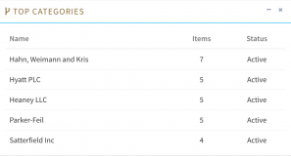

**Top Suppliers**

This is the list of the suppliers that you are associated with and there is also a list of all the items in your store from the associated suppliers.

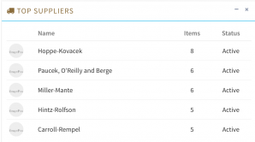

**Need Help?**

If you are stuck anywhere and need some help with your shop, then you can directly contact IndoMarche’s merchant support helpline. You can contact by opening a support ticket from your merchant account page.

To open the support ticket, click on the support ticket tab on your account section, and then click on the submit a new ticket button and fill the provided form.

ACCOUNT >> SUPPORT TICKETS >> SUBMIT A NEW TICKET

